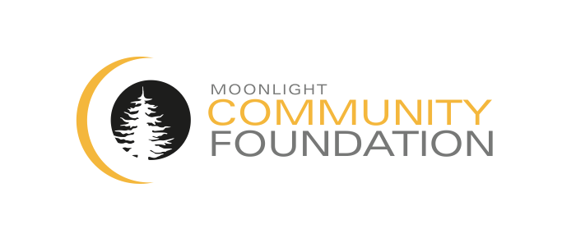

**MCF Grant Application**

Date Submitted:

Deadlines for submittal are May 15th and November 15th

The Moonlight Community Foundation “MCF” funds a variety of programs and initiatives that foster and support opportunities for education, youth development and conservancy that benefit the Big Sky Community.  MCF will consider requests for funding that meet the overall mission and goals of the Foundation. Each request for funding shall be considered in earnest by the Board of Directors. Please review the eligibility documents and grant criteria before completing this application.

Please note: This form is designed to be completed electronically (text will wrap in cells to allow for as much space as you will need). Once completed electronically, please save as new file with your organization’s name in the title of the document and email to [info@moonlightcommunityfoundation.org](mailto:info@moonlightcommunityfoundation.org) . Supporting documents (IRS Form 990, financial statements, operating budgets etc.) can be printed and mailed to:

Moonlight Community Foundation

ATTN: MCF Grants

P.O. Box 161013

Big Sky, Montana

|  |  |  |  |  |  |
| --- | --- | --- | --- | --- | --- |
| Applicant Information | | | | | |
| Organization Name: | | | | | |
| Address: | | | | | |
| City: | | State: | | | ZIP Code: |
| Phone: | Fax: | | | Web Site: | |
| Year Founded: | | | EIN: | | |
| Lead Contact Name (Title): | | | | | |
| Phone: | Fax: | | | email: | |

|  |  |
| --- | --- |
| Project Title: | |
| Funding Requested from MCF: $ | Total Program Budget: $ |

|  |  |
| --- | --- |
| Project Details | |
| Project Description: | |
| Project Start Date: | Project End Date: |
| Please state the need for the project, along with evidence of that need: | |
| Describe the Target Population and Number of Individuals to be served: | |
| What impact will this project have? How will you measure it? | |
| Why is this Project important to your organization? | |
| Provide details of the Implementation Plan: | |
| If the project is a collaborative effort, please provide specifics and list all partners: | |
| Provide details regarding any other funding sources for the project: | |
| What are future funding plans for the project: | |
| Staff responsible for the Project: | |

|  |  |  |
| --- | --- | --- |
| Organization Details | | |
| Mission Statement: | | |
| History of the Organization: | | |
| Description of Current Programs: | | |
| What makes your organization unique: | | |
| Total Employees: |  |  |
| Full Time: | Part Time: | Volunteers: |

|  |  |  |  |  |
| --- | --- | --- | --- | --- |
| Board of Directors | | | | |
| Director Name: | Position: | | Prior Experience: | |
|  |  | |  | |
|  |  | |  | |
|  |  | |  | |
|  |  | |  | |
|  |  | |  | |
| Financial Information | | | | |
| Operating budget: | |  | |  |
| Endowment: | | Value: | |  |
| Do you carry GL and D&O insurance: | | Carrier: | |  |
| Do you have any pending litigation: | | Details: | |  |
|  | |  | |  |
| Top 5 Funding Sources | | | | |
| Source: | Amount ($): | | |  |
|  |  | | |  |
|  |  | | |  |
|  |  | | |  |
|  |  | | |  |
|  |  | | |  |

|  |
| --- |
| Please attach (if available) |
| 1. IRS Form 990 |
| 1. Year-to-Date Financial Statement |
| 1. Current Approved Operating Budget |
| 1. IRS Charitable Status Determination Letter |
| 1. Bios of Board Members |
| 1. Detailed Program Budget |
|  |